Amazon Affiliate Marketing

Company: Aventra Commerce
Reporting and Analysis

Business Problem
Aventra Commerce is a mid-sized e-commerce marketplace that generates revenue through affiliate commissions across multiple product categories, including electronics, kitchen appliances, and home goods. While the platform attracts traffic from various channels such as social media, organic search, and referral platforms, the company has been experiencing inconsistent conversion performance and uneven revenue contribution across markets, devices, and traffic sources.
Despite strong user acquisition, Aventra Commerce faces several key challenges:
- A large portion of users remain in the early stages of the funnel (awareness and interest) without progressing to purchase
- Certain high-potential markets show strong engagement but low revenue contribution
- The effectiveness of discount strategies and pricing tiers is unclear
- Some traffic sources generate high engagement but low return on investment (ROI)
To address these challenges, the analytics team was engaged to:
- Identify key revenue drivers across markets, products, and traffic sources
- Analyze user behaviour across devices and funnel stages
- Evaluate the impact of discounts on conversion and commission performance
- Provide data-driven recommendations to improve conversions, optimize marketing spend, and maximize commission revenue
Key Business Questions:
Unclear Revenue Drivers
We generate a large volume of affiliate clicks, but we do not clearly understand which products and categories consistently generate revenue and commission.
Risk: Time and content effort may be spent promoting low-value products.
Base Level Questions
- Which products generate the highest total affiliate commission revenue, and how many conversions do they account for?
- Which product categories are the top and bottom performers based on total affiliate revenue and average commission per conversion?
Deep Level Questions
- How does product price range (low, mid, high) impact conversion volume, revenue, and commission earned?
- Are there products or categories with high click volume but low conversion or commission, indicating inefficient promotion?

Conversion Funnel Drop-Off
Many users click affiliate links but do not complete purchases, and we lack visibility into where users drop off in the journey.
Risk: Lost commission opportunities and inefficient traffic monetisation.
Base Level Questions:
- How does time spent on page before clicking an affiliate link vary by product category, and which categories show high engagement but low conversion rates?
- How do conversion rates and commission earned differ between discounted and non-discounted products?
- How do conversion rates differ between new and returning users?
Deep Level Questions:
- Do discounts have a greater impact on conversion rates for new users compared to returning users?
- How do product ratings and review counts influence conversion likelihood?
- How do conversion rates and engagement metrics differ across device types?
Traffic Source Effectiveness
We invest effort across multiple traffic sources, but we are unsure which sources drive high-quality traffic that actually converts.
Risk: Marketing resources may be misallocated.
Base Level Questions:
- How does new and returning users vary across traffic sources, and how does this impact conversion performance?
- How do engagement metrics (time on page, scroll depth, engagement score) differ by traffic source, and which sources drive high engagement but low conversions?
- Which traffic sources drive the highest average commission per conversion, indicating higher-quality traffic?
Deep Level Questions:
- How do traffic sources compare in terms of conversion volume, conversion rate, and total commission earned? Identify sources with:
- High traffic but low commission efficiency
- Low traffic but high commission per conversion
Device & User Experience Uncertainty
User behaviour differs across devices and regions, but we do not know how this affects engagement and conversion outcomes.
Risk: Poor user experience optimisation for high-value segments.

Base Level Questions:
- Which countries generate the highest total affiliate commission, and how do their conversion rates compare?
- How are users distributed across conversion funnel stages (Awareness, Interest, Consideration, Action) by device type, and which devices show the highest concentration at non-conversion stages?
Customer Value & Retention
We lack clarity on whether new or returning users provide higher long-term value through affiliate conversions.
Risk: Short-term revenue optimisation at the expense of long-term earnings.
Base Level Questions:
- What is the difference in customer lifetime value (CLV) between new and returning users?
- Which user type contributes more total commission revenue overall?
Deep Level Questions:
- Which traffic sources attract higher-value returning users?
Product & Pricing Alignment
Product price, discounts, and ratings vary significantly, but we do not know how these factors influence conversion likelihood and commission earned.
Risk: Promoting products that look good but convert poorly.
Base Level Questions
- Is there a threshold where higher discounts stop improving conversion performance?
- How do product ratings and review counts differ between converted and non-converted products?
Deep Level Questions:
- Do higher-rated products consistently generate higher commission revenue?

Executive Summary
This report analyzes LuminaCart’s affiliate performance across markets, traffic sources, user behaviour, and pricing strategies to identify key drivers of revenue and opportunities for growth.
The analysis shows that Canada and the United States are the primary revenue-generating markets, while countries like Germany and Australia present untapped growth potential due to strong engagement and higher average order values.
From a marketing perspective, Organic Search and Social Media are the most valuable traffic sources, combining high conversion rates with strong commission performance. In contrast, Streaming platforms show low conversion efficiency and may not deliver strong returns on investment.
User behaviour analysis reveals that while a large proportion of users reach the awareness and interest stages, fewer progress to purchase—particularly on mobile devices, where conversion rates are significantly lower despite high traffic.
Pricing strategy plays a crucial role in performance, with moderate discounts (10–20%) generating the highest commission revenue, while higher discounts increase conversion volume but reduce overall profitability.
Overall, the findings suggest that LuminaCart can improve performance by optimizing mobile conversion, focusing on high-performing channels, expanding high-potential markets, and implementing a balanced discount strategy.

Dataset, Tools and Software
The dataset was obtained from Kaggle:
For this project the tools used are:
- MySQL
- Power BI
Methodology
To understand the factors influencing conversions and commission revenue, this analysis combined data from four core datasets:
- User clicks
- Completed conversions
- Product information
- User behaviour
Data Cleaning and Preprocessing
These datasets were first cleaned and prepared using SQL to ensure consistent formatting and accurate relationships between user interactions and purchases.
Data cleaning process included:
- Checking for duplicates
- Missing Values
- Standardizing the data columns and rows
On MySQL, multiple stagging tables were created that corresponded to the original tables. This was done to ensure that no changes were made in the original datasets.
Result:
Conversions Table
The column click_id has 15 missing values in the conversions table. Approximately 10% of conversion records lack an associated click_id, indicating a notable attribution gap in click-level tracking.
To address this issue transparently and preserve data integrity, a new derived attribution flag column was introduced in the analytical staging layer.
- 1 → Conversion has a valid click_id and can be linked to a recorded click event
- 0 → Conversion does not have an associated click_id and cannot be attributed to a specific click
Product Table
Converted string dates to actual date data type.
During data validation, it was observed that a small number of product ASINs appeared multiple times in the product catalog with conflicting product names and attributes. As ASINs are expected to be unique identifiers, this indicates a catalog-level data integrity issue.
Solution:
To prevent incorrect aggregation and misattribution, product-level analysis was conducted using a composite key of product_asin and product_title. This approach preserves product specificity and avoids merging unrelated products under a shared identifier.
Therefore, when analysing product data, in order to retrieve product information, we include both product_asin and product_title in the select statement to identify the single unique products. Same goes when we are joining multiple tables, we will use product_asin and product_title to join on.
User behaviour and Product Table
Missing Data for product category and traffic sources.
15% of categories are not tracked to their corresponding traffic sources.
Relationship Issue between user behaviour table and conversions table
When calculating the total CLV for each customer type (new vs returning), the query that was ran included duplicates values from the conversions table as we joined the user behaviour table on user_id. There were users that converted multiple times. For example:
user | conversion | CLV
U1 | C1 | 1200
U1 | C2 | 1200
U1 | C3 | 1200

When aggregating the sum, the query summed up the entire column for one user which became 3600, which is wrong. The CLV for U1 should be 1200.
Solution:
In power bi, the system understood the problem and automatically gave the right output. To do the same in SQL, we used a CTE to get the maximum value CLV and then summed it up to get the right output.

ERD Diagram
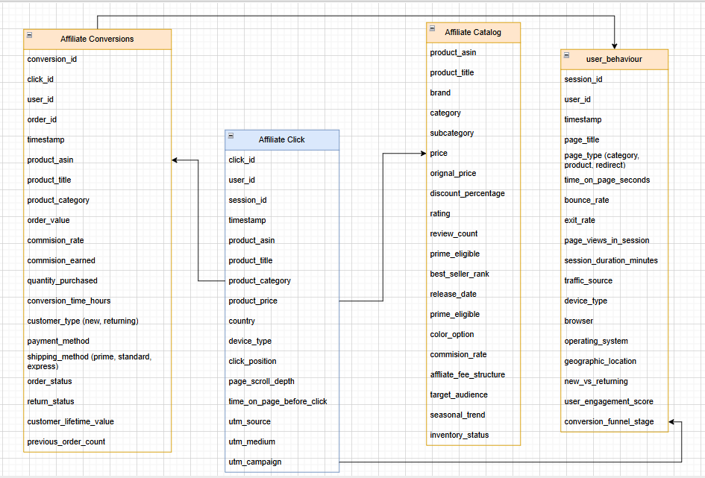

Dashboard Overview
Four dashboards were developed to different departments and stakeholders.
- Executive Performance Dashboard
The executive dashboard is built for high level executives to assess the performance of the business.
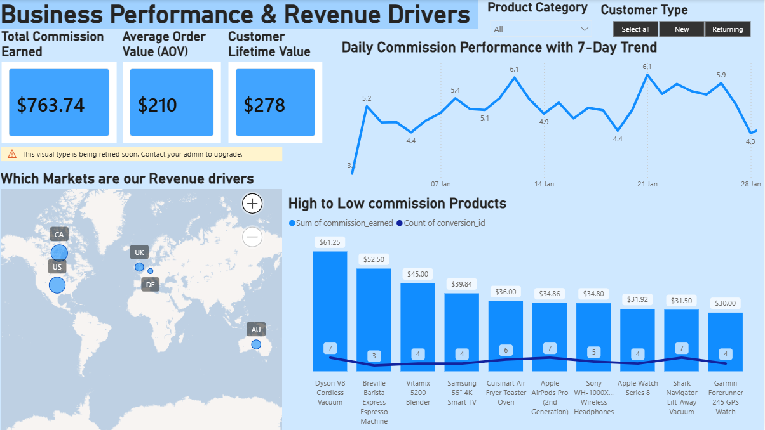
The dashboard helps decide and take actions on:
- Which products needs heavy promotions amongst the top 10 products in terms of high commissions.
- International Markets that drive revenue for our business
- Compare the Average order value with new and returning customers.
- Evaluate revenue momentum across January. Did Promotions or marketing campaigns increase commissions?

- Funnel Performance and Traffic Efficiency
This dashboard is created for the marketing team, specifically the digital marketing experts. The dashboard displays the customer journey in the form of a funnel analysis. Stakeholders using this dashboard can identify which traffic sources can be optimized to bring in more customers and which ones are highly profitable for the company.
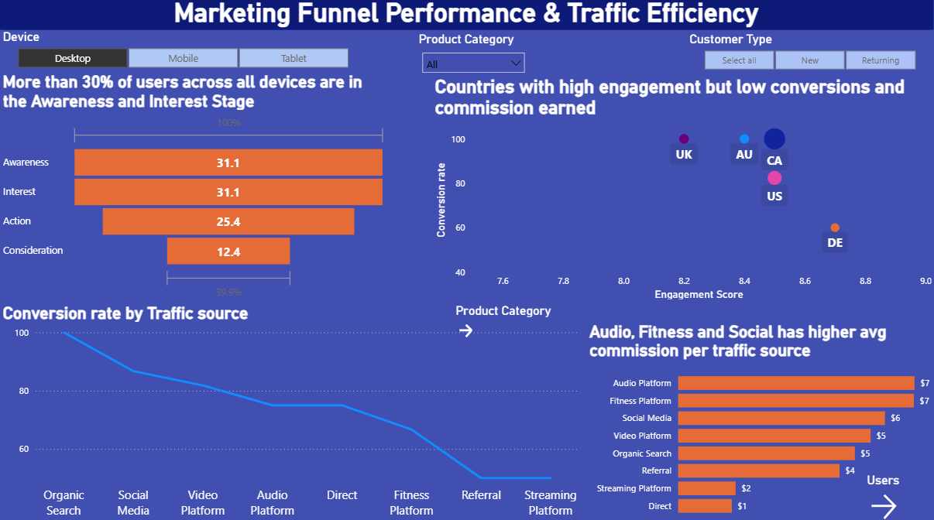

Decisions that can be made from this dashboard include:
- Strategies to push users from Interest and consideration to Action phase.
- Identify and optimize traffic sources that have low conversions rates and continue to promote products on high quality traffic sources.
- Focus on countries with high engagement that has high conversions and bring increased commissions to the business.

- User Interaction and Engagement
This dashboard will be presented to the marketing and UX/UI team. Additionally, this dashboard can help IT team further optimize the website based on user behaviour and engagement.
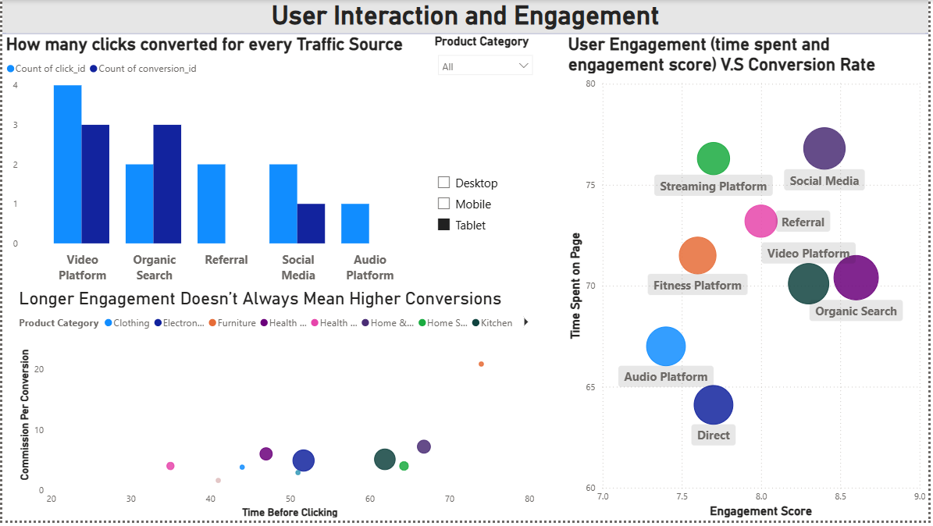
- Sales and Pricing Optimization
The sales dashboard looks at the top selling products from our affiliate business and how does discounts affect conversions and commissions earned.
This dashboard is for the sales team to assess what products we should continue selling and at how much discount should we provide to our customers.
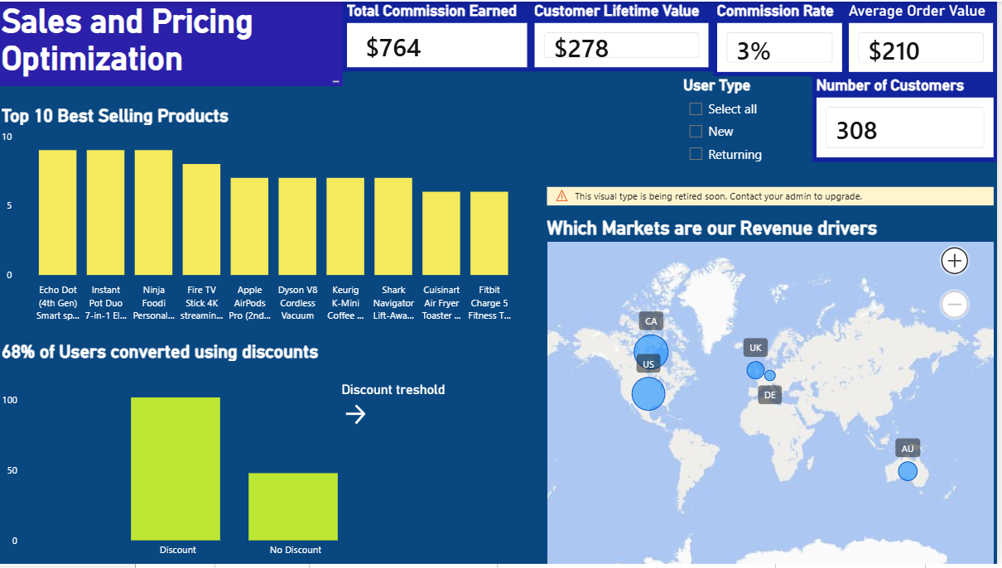
Decisions that can made from the Sales and pricing dashboard:
- Identify top selling products from our business
- Focus selling best sellers to lucrative international markets.
- Compare discounts amongst new and returning customers with AOV and CLV to identify high value customers.

Key Insights and Trends
Market Performance
Ranking countries by total affiliate commissions shows that Canada ($297) and the United States ($275) are currently the strongest markets, generating the majority of revenue.
Country | Total Commission Earned
Canada | $297
United States | $275
Australia | $75
United Kingdom | $61
Germany | $16

Among the lower-performing markets, Germany stands out due to its high engagement score (8.7) despite having only 9 users in January, the lowest user base across all countries. This suggests that while the market is currently small, users who do interact with the platform are highly engaged. Increasing visibility and marketing efforts in Germany could potentially expand the user base and improve revenue performance.
Germany also has the highest Average Order Value (AOV) at $259, indicating strong purchasing potential for higher-priced products.
Australia shows similar potential with an AOV of $252 and a user base of 20 users, suggesting that expanding traffic and product promotions in this market could further increase revenue.
The United Kingdom has a comparable user base (20 users) but the lowest AOV ($193) and lower engagement levels. This suggests that UK users may be more price-sensitive, making them more responsive to targeted promotions or discounts during periods of lower sales activity.
Recommendation
- Maintain strong promotion strategies in Canada and the United States, as they generate the majority of revenue.
- Explore growth opportunities in Germany and Australia by increasing targeted traffic and product visibility.
- Consider price-sensitive promotions in the UK, such as limited-time discounts or bundled offers.

Traffic Sources Effectiveness
The conversion rates for all traffic sources can be seen below:
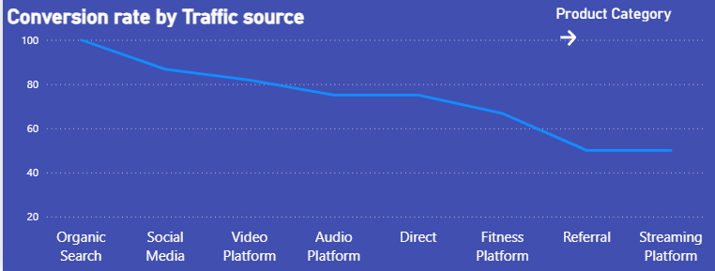
Organic Search shows the highest conversion rate at 100%, indicating that users arriving through organic search likely have strong purchase intent. It is also the second largest traffic source by total users, making it an important acquisition channel for the business.
Users from Organic Search also demonstrate high engagement, with an average engagement score of 8.6 and spending approximately 70 seconds on the website on average. This suggests that users who actively search for the platform are more intentional in their browsing and are more likely to convert quickly.
Social media generates the highest number of users and contributes strong revenue performance, with an average commission of $6 per conversion and a conversion rate of 87%. This indicates that social media is an effective channel for attracting both traffic and revenue-generating users.
Audio and Fitness Platforms generate higher commissions per conversion (around $7) but have conversion rates below 80%. This suggests that while these channels attract valuable purchases, there may be opportunities to improve conversion performance through better targeting or optimized landing pages.
Streaming and Direct sources generate lower commissions (below $2). Direct traffic maintains a moderate conversion rate of 75%, indicating stable performance. However, Streaming platforms show the lowest conversion rate at 50%, suggesting that traffic from this channel may not be highly purchase-oriented and could lead to lower marketing efficiency.
On tablet devices, Video Platforms demonstrate a strong conversion rate of 81%, suggesting an opportunity to better target tablet users through optimized video advertising campaigns.
Recommendations
- Continue strengthening SEO strategies to maintain strong performance from Organic Search and attract high purchase-intent users.
- Maintain investment in Social Media marketing, as it generates the largest user base while also delivering strong commission performance.
- Optimize Audio and Fitness Platform traffic by improving landing pages or targeting strategies to increase conversion rates.
- Reassess marketing spend on Streaming platforms, as the low conversion rate suggests a lower return on marketing investment.
Funnel Analysis
Note: Funnel stages represent user interactions at different stages rather than a strict sequential journey, which explains why some users appear to move directly from interest to purchase.
Across all device categories (Desktop, Mobile, and Tablet), more than 30% of users remain in the Awareness and Interest stages of the funnel. This suggests that a large portion of users are discovering and engaging with products but may not always progress further toward purchase.
The Action stage exceeds 10% across all devices, indicating that a meaningful share of users eventually completes a purchase.
Breaking down the funnel by device reveals differences in how users progress through the purchase journey.
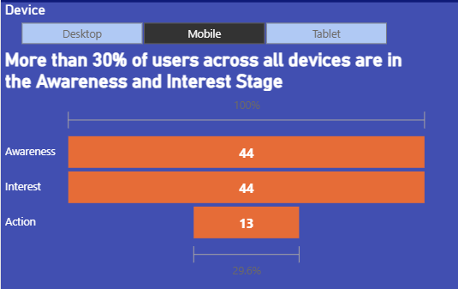
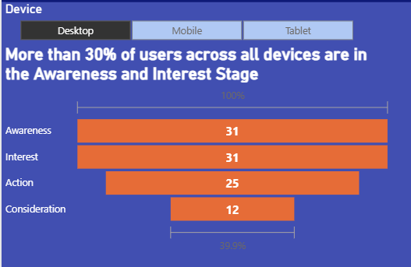

Mobile
Desktop

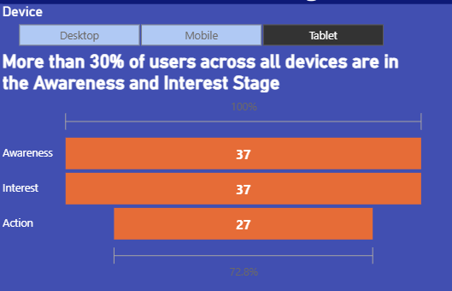
Tablet

Desktop
Desktop users show strong awareness and interest in the products, with 31% of users in both stages. While 25% of users reach the Action stage, only 12% appear in the Consideration stage.
This pattern suggests that many desktop users may move directly from interest to purchase without spending significant time comparing alternatives. This could indicate that returning users or highly motivated buyers prefer desktop devices when completing purchases.
Mobile
Mobile users demonstrate the highest Awareness and Interest levels (44%) among all devices. However, only 13% of users proceed to the Action stage, indicating a significant drop-off before purchase.
This suggests that while mobile devices are effective at attracting users and generating interest, there may be barriers preventing users from completing purchases. Possible factors include mobile user experience, navigation friction, or less optimized checkout flows.
Tablet
Tablet users show 37% Awareness and Interest, similar to other devices. However, 27% of users reach the Action stage, which is the highest purchase rate across devices.
This suggests that tablet users who discover the platform are relatively more likely to complete purchases compared to mobile users.
Key Insights
• Mobile devices are the largest driver of awareness, but they experience the largest drop-off before purchase.
• Desktop users show efficient progression from interest to purchase, possibly indicating stronger purchase intent.
• Tablet users demonstrate the highest action rate, suggesting that users browsing on tablets may have a higher likelihood of completing purchases.
Recommendations
• Improve the mobile purchasing experience, focusing on optimized landing pages, clearer call-to-action buttons, and a smoother checkout process to reduce drop-offs.
• Continue leveraging SEO and social media channels to drive awareness, particularly for desktop and tablet users who show stronger purchase progression.
• Explore targeted promotions or product recommendations for mobile users to encourage them to move from interest to purchase.

User Engagement
Users have different behaviours when it comes to spending time exploring various product categories.
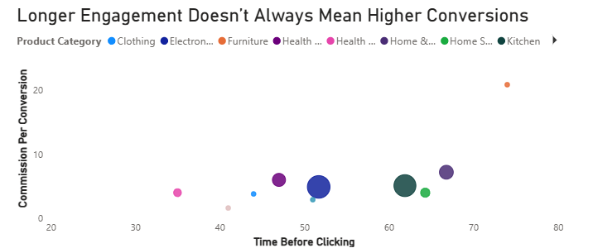

Just because a user spends more time on the website, it doesn’t necessarily lead to many conversions.
The average time spent before clicking is about 50 seconds. Despite that we can see that there is no correlation or causation between the user time before clicking and no. of conversions.
Clicks to Conversions for every traffic source:
Social media and organic search gets the highest number of clicks which eventually turns to high conversions for desktop users.
For mobile devices social media still remains as a strong favourite for clicks and conversion ratio. Fitness platform and organic search tie as the second highest for clicks to conversion ratio despite being a small fraction i.e., 5 clicks and 3 conversions for fitness platforms.
On tablet, video platforms get the highest clicks compared to the rest of the sources at 4 clicks and 3 conversions.
How does user engagement affect conversion rate for traffic sources
The user interaction is judged on the basis of the time spent on the page and the engagement score given.
Key Insights:
Social Media wins on attention. Highest time on page suggests deep content consumption — great for brand building, but conversion could be optimised with stronger CTAs.
Direct and audio platform converts at 75% despite being low on engagement score and time spent. This could mean that users are aware of the products and already have a high purchase intent.

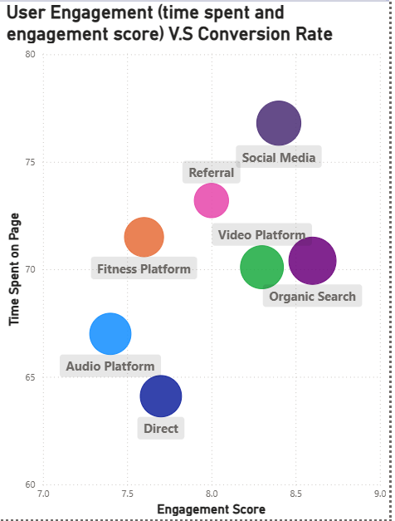

Recommendations:
- Display targeted ads on several popular fitness platforms for mobile devices to draw more clicks and build awareness about our website and products.
- Partner with various popular video platforms like YouTube, Vimeo and Dailymotion to display ads on tablet devices.
- Add stronger mid-content CTAs — users are engaged but may not be guided toward a decision. Launch retargeting campaigns for users who spent significant time on page but didn't convert.
- Further optimize ads on audio platforms using display ads along with ads on podcasts to increase engagement and help users explore our website.

Product and Pricing Strategy
Electronics and Kitchen categories emerge as the top-performing segments, each contributing over 50 product sales. This indicates strong customer demand for functional and high-value household and tech products.
The top-selling products are led by items such as smart home devices, kitchen appliances, and personal electronics, highlighting a preference for practical and utility-driven purchases.
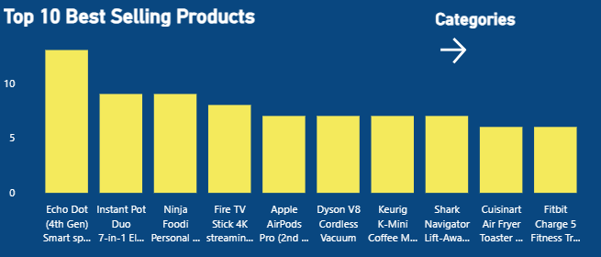

For earning high commissions, promote products like:
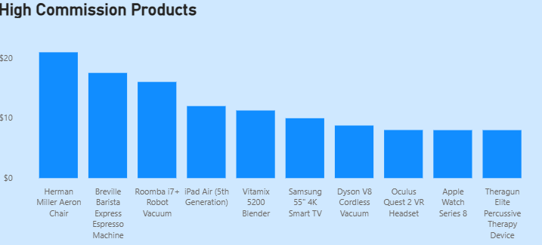
In terms of revenue efficiency, several products generate high average commissions per sale, including premium items such as high-end appliances and electronics. Notably, the Dyson V8 Cordless Vacuum stands out as both a top-selling and high-commission product, making it a key candidate for targeted promotions.
Discount Impact on Revenue
Discounting plays a significant role in driving conversions:
- 68% of users converted using discounted products
- Discounted purchases generated $495 in commission, compared to $269 from non-discounted purchases
This clearly indicates that discounts are a major driver of both conversions and revenue.
Categories such as Kitchen and Home & Garden show particularly strong responsiveness to discounts, suggesting that users in these categories are more price-sensitive.
In contrast, categories like Furniture, Clothing, and Sports & Outdoors show lower sales volumes, which may be partly due to limited discounting. For example, the Furniture category has a high AOV (~$1000), indicating strong revenue potential if supported with strategic pricing incentives.
Optimal Discount Strategy
Analysis of discount tiers shows that:
- Moderate discounts (10–20%) generate the highest total commission ($316)
- High discounts generate lower commission ($209) but achieve a higher conversion rate (76%)
- Low discounts perform the weakest across both metrics
This highlights a key trade-off:
- Moderate discounts → maximize revenue (commission)
- High discounts → maximize conversions (volume)

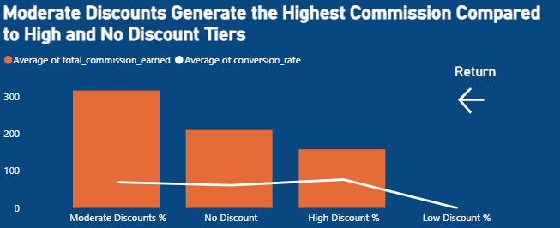
Key Insights
• Revenue is driven by a mix of high-demand categories (Electronics, Kitchen) and high-commission products.
• Discounts significantly influence purchasing behavior, contributing to the majority of conversions.
• Moderate discounting provides the best balance between profitability and conversion performance.
• High AOV categories like Furniture remain underutilized opportunities due to limited discounting strategies.

Recommendations:
- Apply moderate discounts (10–20%) as a standard pricing strategy to maximize overall commission.
- Use high discounts selectively during peak or promotional periods to boost conversion volume.
- Prioritize promotion of high-performing products (e.g., Dyson V8, Shark Navigator) to maximize commission per sale.
- Introduce targeted discounts in high AOV categories (e.g., Furniture) to unlock additional revenue potential.
- Continue focusing on Electronics and Kitchen categories, as they consistently drive both volume and revenue.

Final Recommendations
1. Optimize Mobile Conversion Experience
Mobile devices drive the highest awareness but have the lowest conversion rates. Improving mobile UX, simplifying checkout flows, and strengthening call-to-action elements can reduce drop-offs and increase conversions.
2. Leverage High-Performing Traffic Sources
Continue investing in Organic Search and Social Media, as they generate strong conversion rates and revenue.
Optimize Audio and Fitness platforms to improve conversion efficiency, as they already generate high commission per sale.
3. Reassess Low ROI Channels
Reduce or carefully monitor spending on Streaming platforms, as they show the lowest conversion rates and may not provide strong returns.
4. Expand High-Potential Markets
Increase marketing efforts in Germany and Australia, where engagement and AOV indicate strong growth potential despite lower current revenue.
5. Implement a Tiered Discount Strategy
- Use moderate discounts (10–20%) as the standard strategy to maximize revenue
- Apply higher discounts during peak seasons to drive customer acquisition and volume
6. Promote High-Value Products and Categories
Focus on Electronics and Kitchen categories, along with high-commission products (e.g., premium appliances), to maximize profitability.
7. Target Returning Customers
Returning customers generate higher value per purchase (avg commission 5.3 vs 4.9). To maximize this segment:
- Promote high-commission products (e.g., premium electronics, appliances) through personalized recommendations
- Use email and retargeting campaigns to re-engage past users
- Offer moderate discounts (10–20%) and loyalty incentives to drive repeat purchases

Limitations
1. Limited Timeframe (Single Month Data)
The analysis is based solely on data from January. As a result, trends such as seasonality, month-over-month performance, and long-term customer behaviour could not be evaluated. Insights may not fully represent performance across different time periods.
2. Funnel Stage Interpretation
The funnel stages (Awareness, Interest, Consideration, Action) do not follow a strictly sequential pattern in the dataset. In some cases, users appear to move directly from early stages to purchase, which limits the ability to accurately measure drop-off rates between stages.
3. Data Granularity and Join Complexity
The dataset contains multiple records per user and per click in certain tables, which can lead to inflated metrics (e.g., commission values) when joining tables. While aggregation techniques were applied to mitigate this, there may still be minor inconsistencies in calculated metrics.
4. Attribution Gaps
There are instances of unattributed clicks (missing or null click IDs), which may impact the accuracy of conversion rate calculations and traffic source analysis.
5. Limited Product-Level Consistency
Product identifiers such as product ASIN contain duplicates with varying product titles, which may introduce inconsistencies when analyzing product performance or applying joins across tables.
6. Lack of External Factors
The dataset does not include external variables such as competitor pricing, marketing spend, or seasonal campaigns. As a result, the analysis cannot fully explain why certain trends occur.
Assumptions
1. Conversion Definition
Each conversion record is treated as a successful purchase event, and associated commission values are assumed to accurately represent revenue contribution.
2. Click-to-Conversion Relationship
It is assumed that each conversion is correctly linked to a click ID, even though some clicks may have multiple associated conversions.
3. User-Level Aggregation
Where multiple records exist for a single user, aggregated values (e.g., average engagement score) are assumed to represent overall user behavior.
4. Discount Impact
Discount percentages are assumed to directly influence conversion behavior, although other unobserved factors (e.g., product demand, brand preference) may also contribute.
5. Device and Traffic Source Behaviour
User behaviour across devices and traffic sources is assumed to be representative of typical usage patterns, despite the limited timeframe and sample size.

